How do I accept transferred tickets?
How do I accept transferred tickets?
Accepting tickets is easy! Follow these steps and you’ll have your tickets in no time. It’s always a good idea that you know and trust the person transferring tickets to you.

Accept Tickets via Email
- Tap the Accept Tickets link in your email.
- Log in or create a new account in TM. Be sure to use the email address that the tickets were sent to. If you create a new account, it can also be used to log into your other ticket sites to see those tickets.
- View your tickets by tapping View Tickets or by going to My Events.

Learn more about adding your tickets to your mobile wallet. – see below

Accept Tickets via Text
- Tap the Login link in your text messages.
- Log in or create a new account in TM.
NOTE: Accepting season tickets or a ticket series? You may be directed to the team or venue’s Account Manager site.
- View your tickets by tapping View Tickets or by going to My Events.

Learn more about adding your tickets to your mobile wallet – see below

How to add tickets to a digital wallet

Adding tickets to a digital wallet is not available for Android users at this time. Fans with the latest version of iOS can follow the steps below:
- In the Ticketmaster app, sign in to your account.
- Tap My Events to view your order.
- Tap on Add to Apple Wallet
Please Note: Adding tickets to a digital wallet is optional. It is not necessary to gain entry. You can access your tickets from the Ticketmaster App or by going to www.ticketmaster.com on your mobile browser if you are experiencing issues adding tickets to a digital wallet.

Commonly Asked Questions

Will the person sending the tickets know I accepted them?
Once you accept the ticket, the sender will receive a notification that the tickets have been successfully transferred.

Will the person I transfer tickets to need a Ticketmaster account?
Yes, and it takes just a few seconds to create one. If they already have an account, be sure to use the email address associated with their Ticketmaster account, so it's even easier for them to accept their tickets.
Learn more about Create a Ticketmaster Account.

I lost the email/text for my transferred tickets. What do I do?
Ask the sender to cancel the original transfer and to transfer the tickets again. Still not finding them? Try searching your email using the term “transfer” or by searching for the artist or event.

I accepted tickets but can't find them.
Do you have another Ticketmaster account? Were you using a device that was logged into another account? Or did you accept tickets from a team or venue’s official site? If you accepted tickets on a different site, log in to that site and transfer them to the account you want them in.
It is also possible that they are located in the team or venue's official site or app, which is separate from your Ticketmaster account. Locate your tickets by logging into your account associated with the team or venue.
NOTE: Try referencing your purchase confirmation email or ticket transfer email.

How to add tickets to a digital wallet
How to add tickets to a digital wallet

Adding tickets to a digital wallet is not available for Android users at this time.
Fans with the latest version of iOS can follow the steps below:
- In the Ticketmaster app, sign in to your account.
- Tap My Events to view your order.
- Tap on Add to Apple Wallet
Please Note: Adding tickets to a digital wallet is optional. It is not necessary to gain entry. You can access your tickets from the Ticketmaster App or by going to www.ticketmaster.com on your mobile browser if you are experiencing issues adding tickets to a digital wallet.

Create a Ticketmaster Account
Create a Ticketmaster Account
You can create an account through the Ticketmaster app, ticketmaster.com, or on a venue or team site/app. Once created, this username and password can be used to login to multiple sites to access tickets.
Beyond buying tickets, what else can you do with an account? Your account allows you to see upcoming events. Get notifications of when your favorite artists, teams, or venues are in town. And allows friends and family to transfer you your ticket.

Create an Account on Mobile
To create an account through your mobile device, follow the following steps:
- Download and open the Ticketmaster App.
- Tap My Account.
- Tap Sign In.
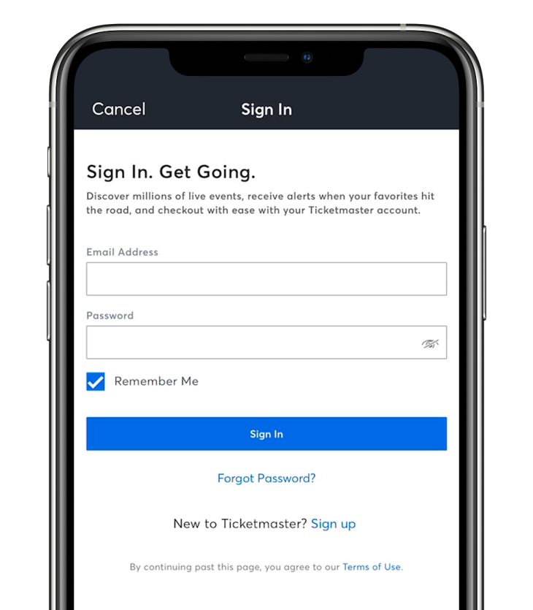
- Tap New to Ticketmaster? Sign Up.
- Enter your name, email address, phone number, password, zip/postal code, and country of residence. Tap Next.
- Select either Text or Call to get your One-Time Code. Tap Next.
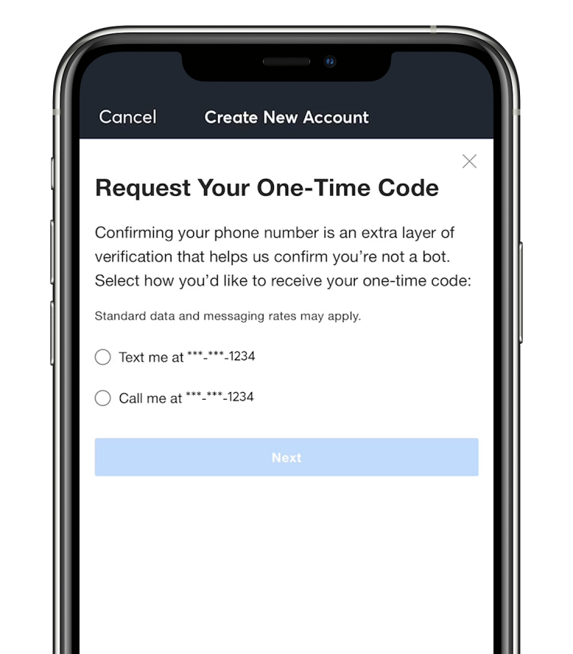
- Enter your One-Time Code, and tap Continue.
NOTE: Standard data and messaging rates may apply.

Create an Account on Desktop
To create an account through your desktop web browser, follow the following steps:
- Go to my.ticketmaster.com/account and select New to Ticketmaster? Sign Up.
- Enter your email address, password, name, country of residence, and zip/postal code. Select Next.
- Enter your phone number to get your One-Time Code. Select Next.
- We will send your One-Time Code to your phone via SMS. Confirm your code and select Confirm.
NOTE: Standard data and messaging rates may apply.

Commonly Asked Questions

It says I already have an account.
If you are getting a message that you already have an account, select Sign in. If you cannot remember your password, follow the link to reset it.
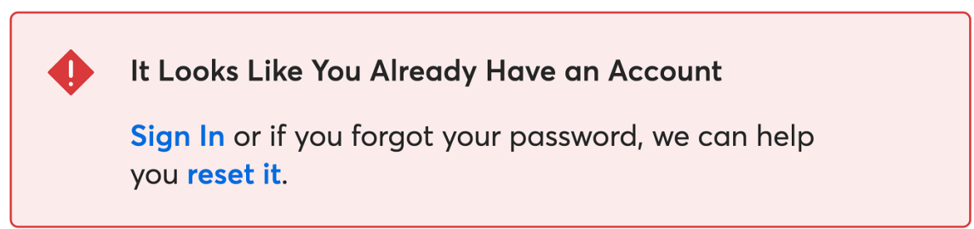

I have not received my One-Time Code.
If you have not received your One-Time Code, select Request a New Code.
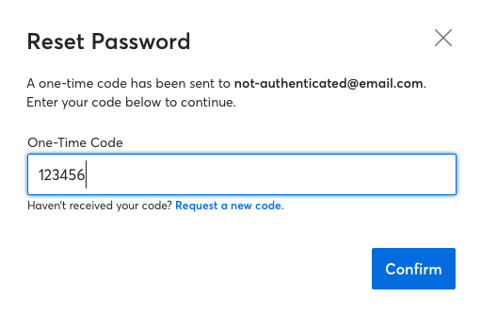

I forgot my password.
To reset your password, find the instructions here.

I don’t have a mobile device/SMS messaging. How do I verify my account?
A landline phone can also be used to verify your account. You will not need to indicate that the number is a landline. If your number is recognized as a landline, we will call and provide you with a code to verify your account.

Is it free to create an account?
Yes! It is free to create a Ticketmaster account.

Someone in my household has an account, should I create one?
By having your own account, you can have tickets sent to you by your friends and family. Eliminating any worry of sharing account login details, and you can have your own ticket in-hand!

